**Tall Corner Wall Shelf**

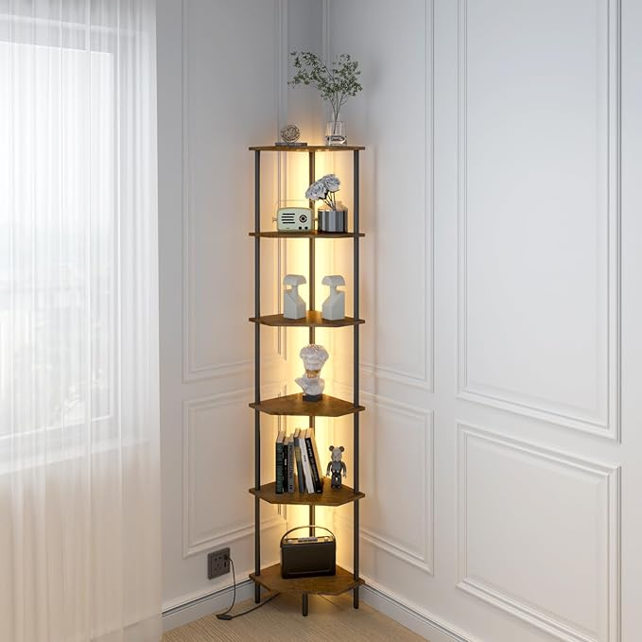A tall corner wall shelf is a smart and stylish solution for maximizing space in any room. Designed to fit snugly into corners, this vertical shelving unit provides multiple tiers for displaying books, plants, photos, or decorative items. Its sleek and compact design makes it perfect for small spaces, while its height adds visual interest and utility. Whether crafted from wood, metal, or a combination of materials, a tall corner wall shelf complements various interior styles, offering both practicality and aesthetic appeal.

.